VOLUNTEER READERS WANTED

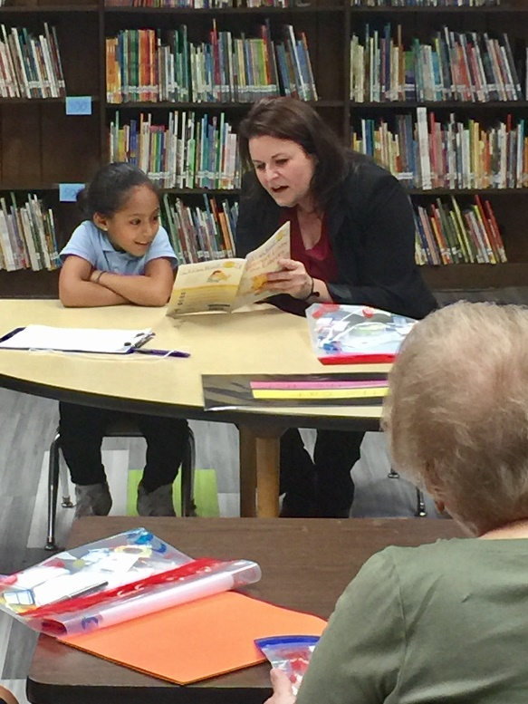

First 2018-2019 Training Session
Friday, October 5, 2-3:00 p.m.
Jackson Early Childhood Center
517 N. 15th Street, Allentown, PA
Principal: Josh Radcliffe
Trainer: Melissa Smith, ASD Director of Literacy

SIGN-UP FORM
NAME ________________________________________________________________
ADDRESS _____________________________________________________________
CITY______________________________ STATE _______ ZIP _________________
PREFERRED ELEMENTARY SCHOOL (if any) ________________________________
PHONE NUMBER ______________________________________________________
PHONE ____________________________EMAIL______________________________
(Email this form to newhardv@allentownsd.org or mail to ASDF, 31 South Penn Street, Allentown PA 18102)

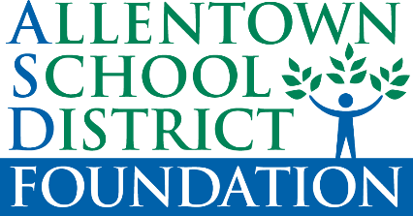
The first 2018-2019 training session for the Allentown School District Foundation volunteer reading program is scheduled for Friday, October 5, from 2:00-3:00pm at Jackson Elementary Childhood Center located at 517 North 15th Street in Allentown. Parking is on the street. Background clearances are required and directions to obtain them will be distributed. Reading to kindergartners in 60 classrooms in 14 schools across the city is the priority. Looking for 100 volunteer readers this year! Please contact Vicki at newhardv@allentownsd.org or by calling 484-765-4121. Please RSVP by October 3. Thank you.

